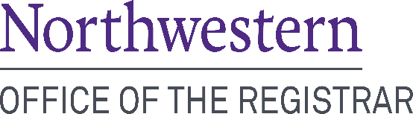 | 633 Clark Street  Office use:  Date received__________ Staff initials_________  Payment method_________ Date paid___________  Evanston, Illinois 60208  (847) 467-0760 Phone  (847) 491-8458 Fax
Request for Replacement Diploma

Date Requested: ______________ Student ID Number: ____________________

Name while attending Northwestern University: ______________________________________________________________
Name to be printed on diploma(s), if different from above: ______________________________________________________
School(s) attended: ____________________________________________________________________________________
Degree(s) awarded: ____________________________________Date(s) awarded (month & year): _____________________

Email Address: ___________________________________________ Phone number: _______________________________

Student Signature _____________________________________________________________________________________

_____ $50.00 hard copy replacement diploma Quantity Requested: ___________

_____ One-week rush: Your request will be processed within one week, not including mailing time. There is an additional $50.00 rush fee. and $75.00 domestic UPS or $125.00 international UPS charge for a total of $175.00 domestic or $225.00 international.

_____ Two-week rush: Your request will be processed within two weeks, not including mailing time. There is an additional $25.00 rush fee and $75.00 domestic UPS or $125.00 international UPS charge for a total of $150.00 domestic or $200.00 international.

_____ Diploma Cover: Your replacement diploma will be mailed in a Northwestern University cover. The cover is Northwestern purple with the University’s seal in gold. There is an additional $20.00 charge for a cover.

_____ $50.00 CeDiploma (Certified electronic diploma) Graduates prior to June 2021.

_____ One-week rush: Your request will be processed within one week. There is an additional $50.00 rush fee, for a total $100.00.

_____ Two-week rush: Your request will be processed within two weeks. There is an additional $25.00 rush, for a total $75.00.

Do not include credit card information on this form. Once your request is received a secured payment link will be emailed. If paying by check please make check payable to: Northwestern University.

____________________________________________________________________________________________________
(Recipient mailing address)
____________________________________________________________________________________________________
(Street address) (City, State, Zip Code, Country)
PLEASE NOTE: The following additional services are available for specialized purposes. Use of these services may delay processing.

Please notarize ______ *Apostille services ______ Not available for CeDiplomas
*For apostille services see instructions on our website: http://www.registrar.northwestern.edu/registration-graduation/graduation-preparation/request-a-diploma.html

